Nama : Ilham Maulana Ramadhan

Nim : 1207070058

Matkul : PCD TSEB

Link Github : <https://github.com/ilhamchuaks/Praktikum-09_Ilham-Maulana-Ramadhan.git>

**PRAKTIKUM 09 EDGE DETECTION**

1. Filter Canny

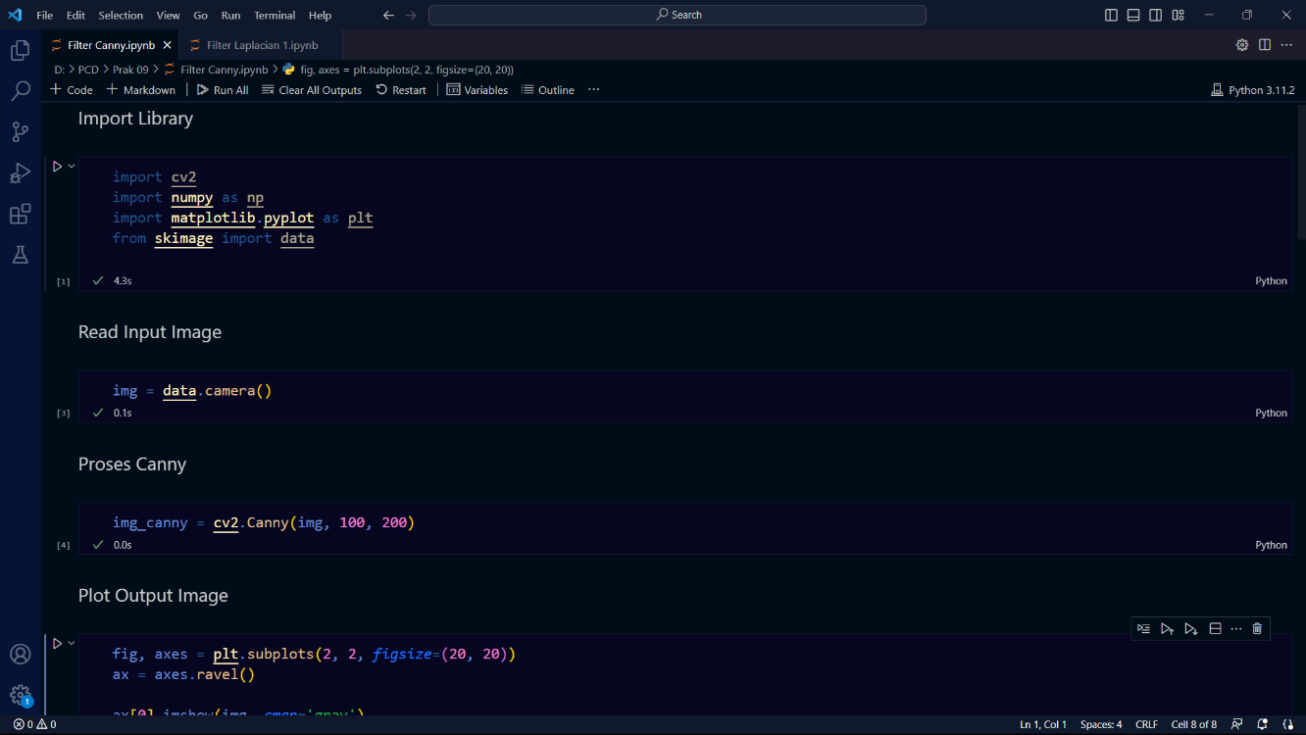

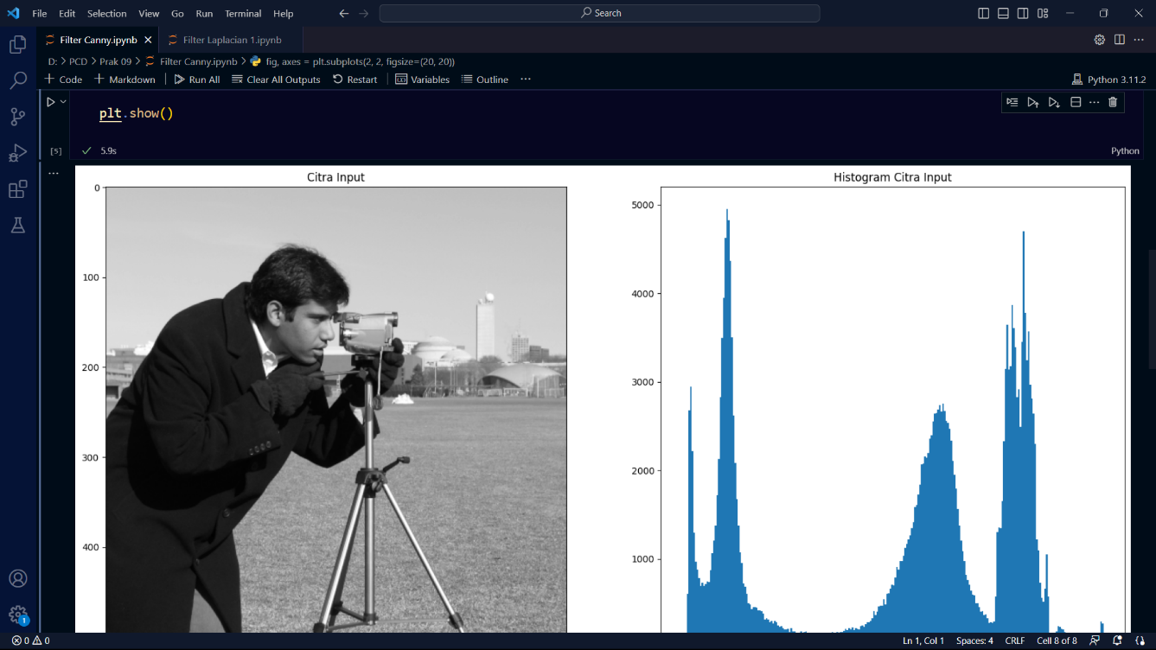

1. Filter Laplacian 1

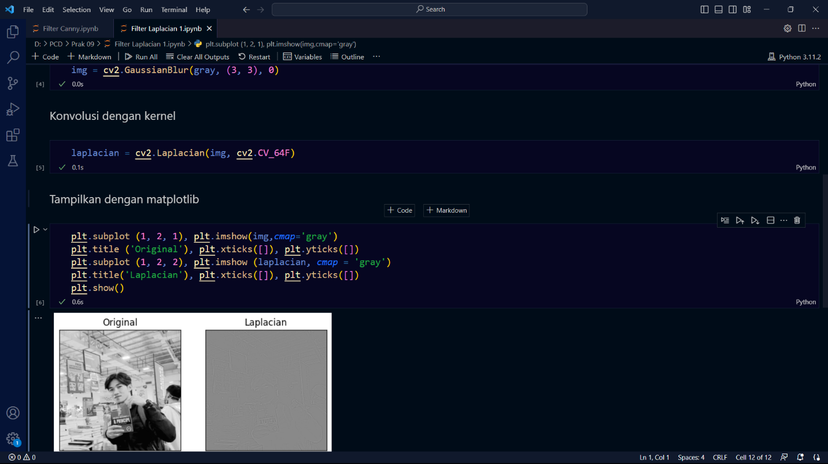

1. Filter Laplacian 2

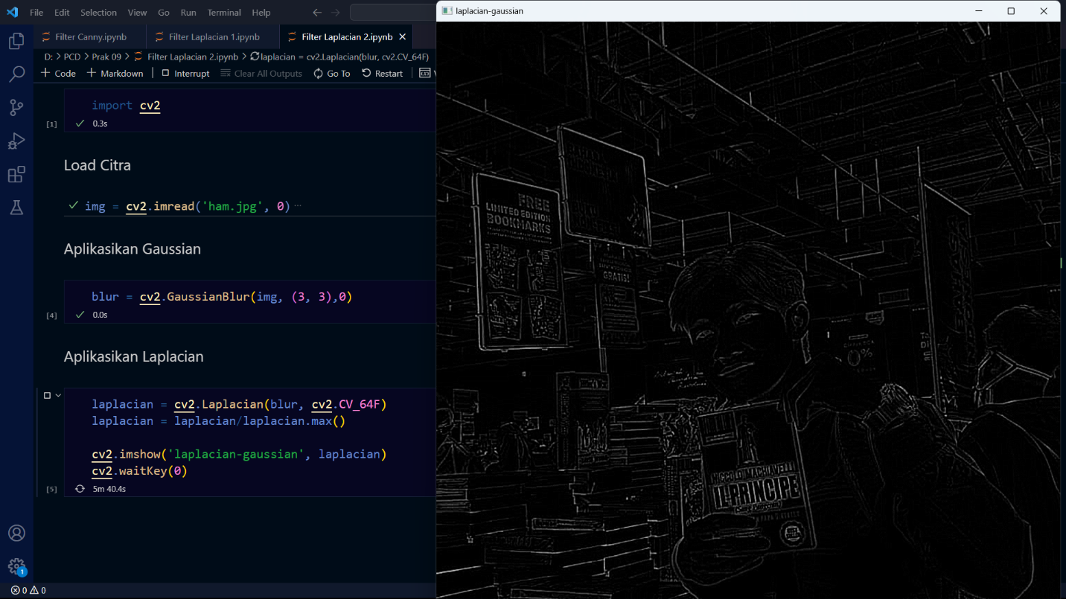

1. Filter Prewitt

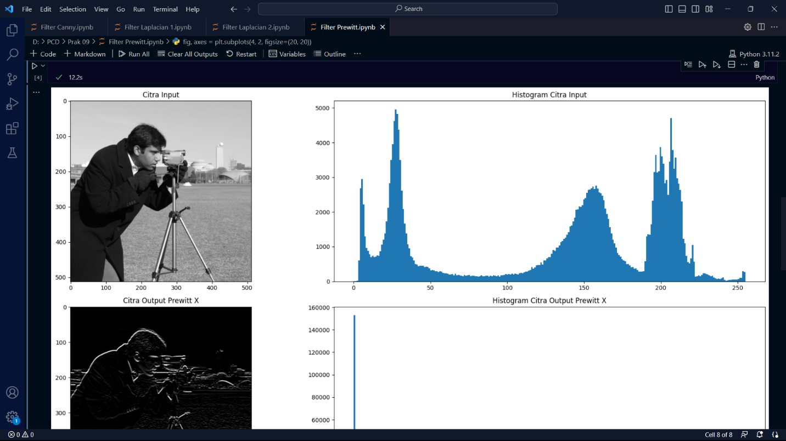

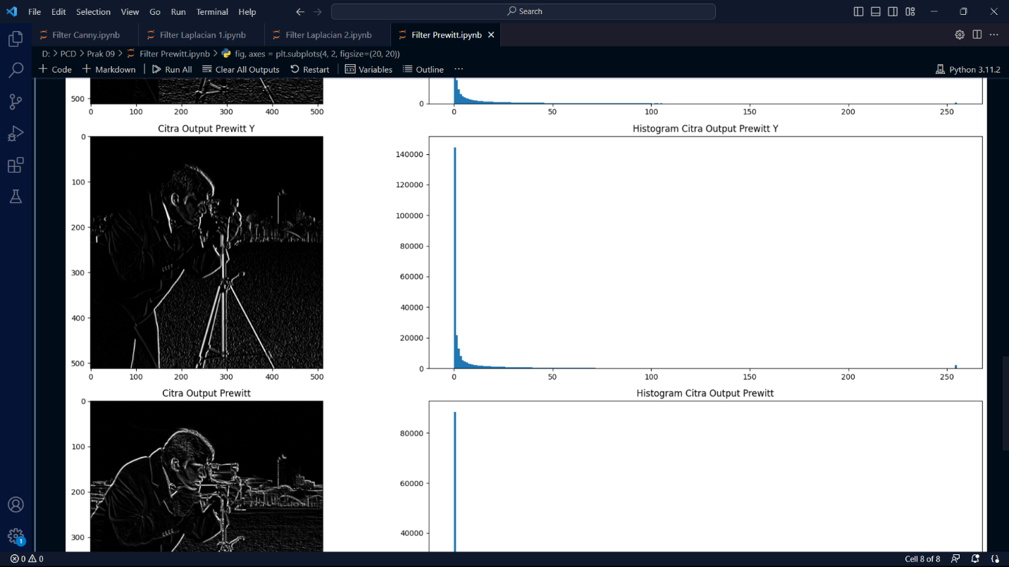

1. Filter Sobel

